Homework 4 for **Kun**

Introduce to image process

All codes are attached on the last page.

Edge Detection:

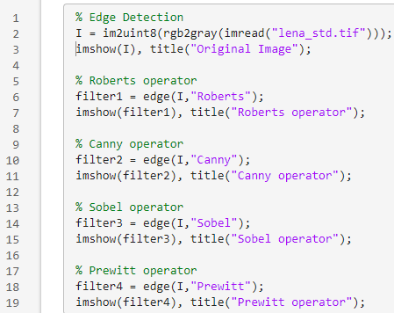

Res:

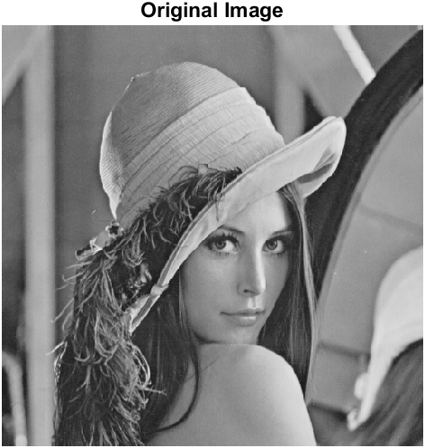

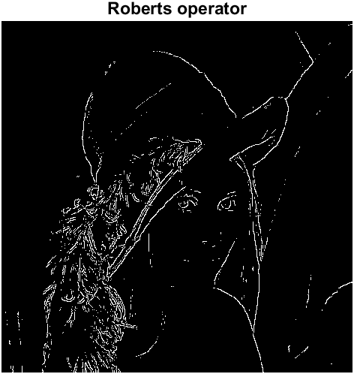

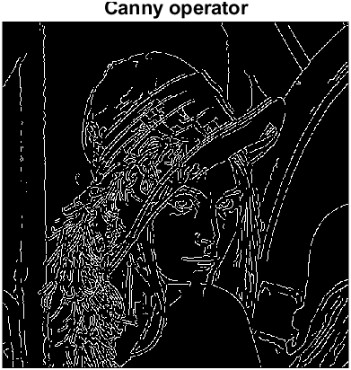

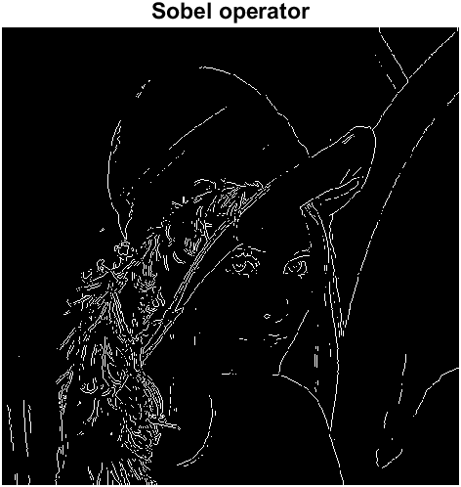

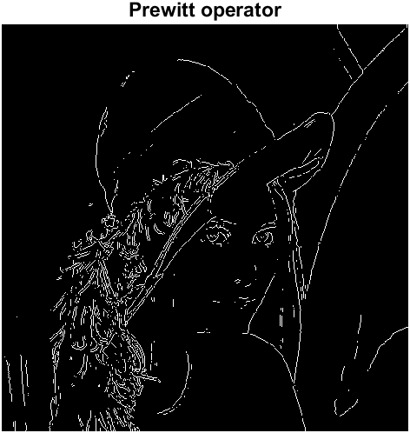

I think Sobel Operator gives the best performance, because

Edge Filter

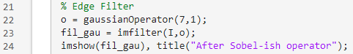

Res:

Operator: The weight for left and right obey for Gaussian rule, more like a gaussian filter.

Image: It seems like more blurred the edge.

Histogram-based segmentation

a

Res

B



Res

C

D

Res

E

Res

Noise Reduction

a

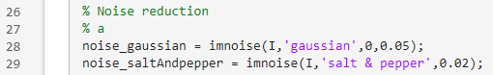

b

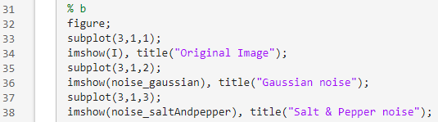

Res:



C

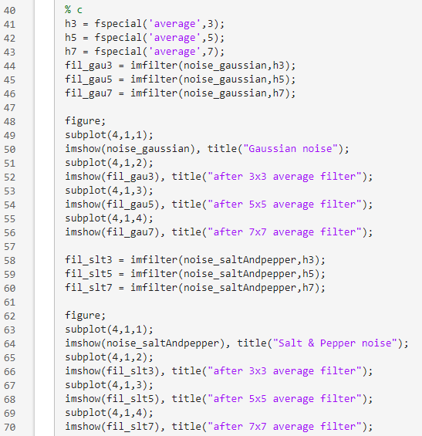

Res:





D

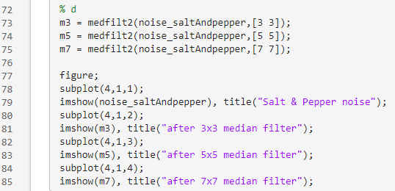

Res:



% Edge Detection

I = im2uint8(rgb2gray(imread("lena_std.tif")));

imshow(I), title("Original Image");

% Roberts operator

filter1 = edge(I,"Roberts");

imshow(filter1), title("Roberts operator");

% Canny operator

filter2 = edge(I,"Canny");

imshow(filter2), title("Canny operator");

% Sobel operator

filter3 = edge(I,"Sobel");

imshow(filter3), title("Sobel operator");

% Prewitt operator

filter4 = edge(I,"Prewitt");

imshow(filter4), title("Prewitt operator");

% Edge Filter

o = gaussianOperator(7,1);

fil_gau = imfilter(I,o);

imshow(fil_gau), title("After Sobel-ish operator");

% Histogram-based segmentation

% a

imshow(I), title("Original Image");

% b

imhist(I), title("Histogram of Original Image");

% c

R1 = [25,75];

R2 = [160,180];

R3 = [200,300];

% d

B1 = uint8(255*((I>=R1(1))&(I<=R1(2))));

imshow(B1), title("binary Image for range "+R1(1)+" to "+R1(2));

B2 = uint8(255*((I>=R2(1))&(I<=R2(2))));

imshow(B2), title("binary Image for range "+R2(1)+" to "+R2(2));

B3 = uint8(255*((I>=R3(1))&(I<=R3(2))));

imshow(B3), title("binary Image for range "+R3(1)+" to "+R3(2));

%e

base = sum(sum(B1))+sum(sum(B2));

m1 = sum(sum(B1.*I))/base;

m2 = sum(sum(B2.*I))/base;

c = m1*B1 + m2*B2;

imshow(c), title("Histogram Segmented Image");

% Noise reduction

% a

noise_gaussian = imnoise(I,'gaussian',0,0.05);

noise_saltAndpepper = imnoise(I,'salt & pepper',0.02);

% b

figure;

subplot(3,1,1);

imshow(I), title("Original Image");

subplot(3,1,2);

imshow(noise_gaussian), title("Gaussian noise");

subplot(3,1,3);

imshow(noise_saltAndpepper), title("Salt & Pepper noise");

% c

h3 = fspecial('average',3);

h5 = fspecial('average',5);

h7 = fspecial('average',7);

fil_gau3 = imfilter(noise_gaussian,h3);

fil_gau5 = imfilter(noise_gaussian,h5);

fil_gau7 = imfilter(noise_gaussian,h7);

figure;

subplot(4,1,1);

imshow(noise_gaussian), title("Gaussian noise");

subplot(4,1,2);

imshow(fil_gau3), title("after 3x3 average filter");

subplot(4,1,3);

imshow(fil_gau5), title("after 5x5 average filter");

subplot(4,1,4);

imshow(fil_gau7), title("after 7x7 average filter");

fil_slt3 = imfilter(noise_saltAndpepper,h3);

fil_slt5 = imfilter(noise_saltAndpepper,h5);

fil_slt7 = imfilter(noise_saltAndpepper,h7);

figure;

subplot(4,1,1);

imshow(noise_saltAndpepper), title("Salt & Pepper noise");

subplot(4,1,2);

imshow(fil_slt3), title("after 3x3 average filter");

subplot(4,1,3);

imshow(fil_slt5), title("after 5x5 average filter");

subplot(4,1,4);

imshow(fil_slt7), title("after 7x7 average filter");

% d

m3 = medfilt2(noise_saltAndpepper,[3 3]);

m5 = medfilt2(noise_saltAndpepper,[5 5]);

m7 = medfilt2(noise_saltAndpepper,[7 7]);

figure;

subplot(4,1,1);

imshow(noise_saltAndpepper), title("Salt & Pepper noise");

subplot(4,1,2);

imshow(m3), title("after 3x3 median filter");

subplot(4,1,3);

imshow(m5), title("after 5x5 median filter");

subplot(4,1,4);

imshow(m7), title("after 7x7 median filter");

function o=gaussianOperator(size,sigma)

o = zeros(size,size);

for i=-(size-1)/2:(size-1)/2

for j=-(size-1)/2:(size-1)/2

x0=(size+1)/2;

y0=(size+1)/2;

x=i+x0;

y=j+y0;

o(y,x)=(x)/(-2*pi*((sigma)^4))*exp(-((x-x0)^2+(y-y0)^2)/2/sigma/sigma);

end

end

sum1=sum(o);

sum2=sum(sum1);

o=o/sum2;

end